Tutorial 1: Entrepreneurship Concepts

1. In your own words, describe the term “software entrepreneur”; and highland the important key

words in your description.  
  
**An entrepreneur who uses different set of cutting-edge developing technologies and/or strategies than other business start-ups to develop new business models**

**The development of software, a digital “soft” good, involves different business models, product strategy, people management, and development plan compared to the traditional manufacturing and service industries**

**whose business involves software and IT technology**

2. Describe some primary reasons why people become entrepreneurs. Among those reasons

described, which are the three most important to you? Discuss.

§§ Reasons To Become One:

* Control over time
* Fulfillment
* Creation/Ownership
* Control over Compensation
  + salary
  + wage
  + dividend
  + commission
* Control over Working Conditions

3. What are the costs of benefits of entrepreneurship? Do you think entrepreneurship is for

everyone? Why?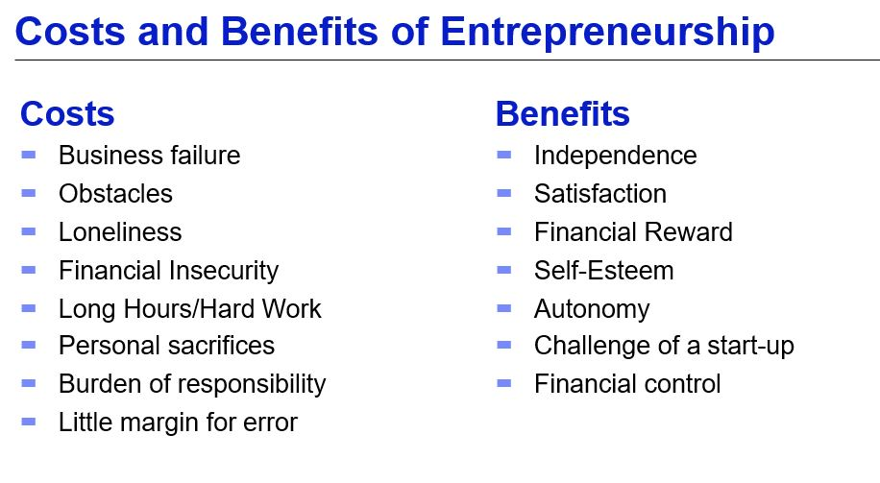

4. Describe the difference between red ocean and blue ocean market place.

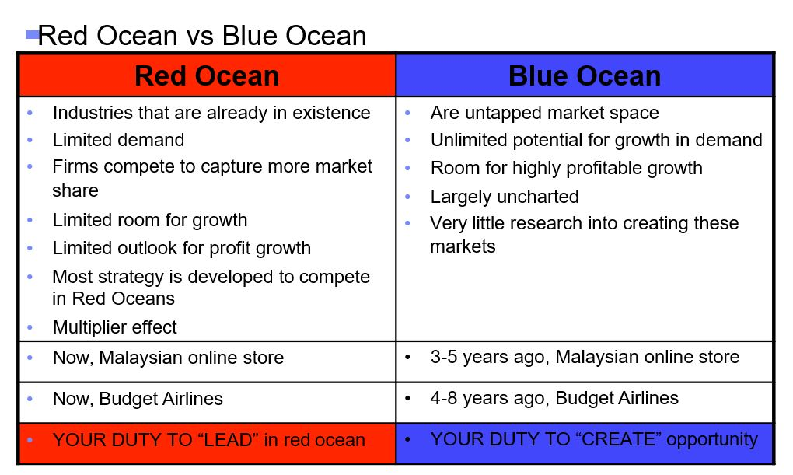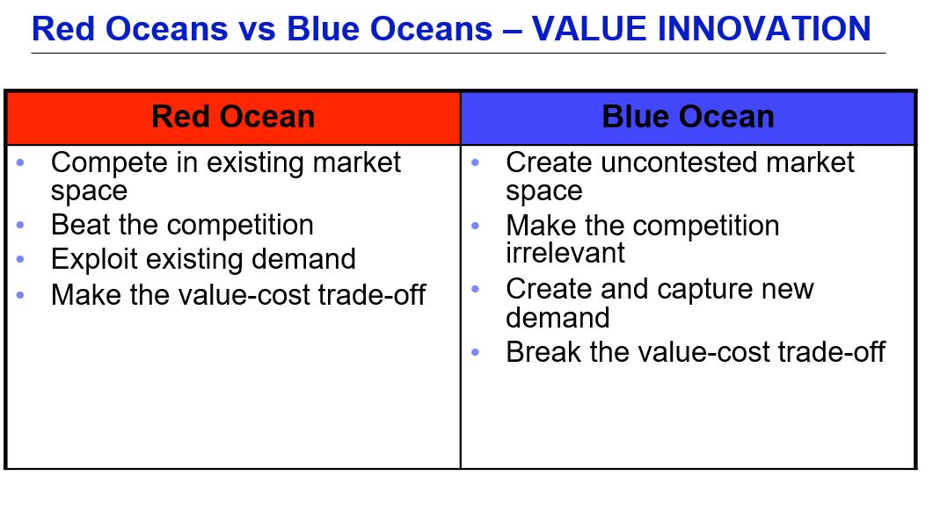

5. List the processes of software entrepreneurship.

